**API Testing Report**  
**Tester:** Zuhaib azhar  
**Date:** July 16, 2025  
**Project:** Localhost Auth API (http://localhost:3000)

**🔐 Task 1: Authentication & Authorization Test**

**📂 Login API: POST /api/auth/login**

**Test Cases:**

|  |  |  |  |  |
| --- | --- | --- | --- | --- |
| **Test Case** | **Input** | **Expected Result** | **Actual Result** | **Status** |
| Valid Login | Correct email & password | 200 OK + Token | 200 OK + Token | ✅ Pass |
| Invalid Password | Correct email, wrong password | 401 Unauthorized | 401 Unauthorized | ✅ Pass |
| Unknown Email | Wrong email | 404 Not Found | 404 Not Found | ✅ Pass |

**🔒 Protected Route: GET /api/user/profile**

|  |  |  |  |  |
| --- | --- | --- | --- | --- |
| Test Case | Token Used | Expected Result | Actual Result | Status |
| Valid Token | Correct token | 200 OK + User Profile | 200 OK + Profile Data | ✅ Pass |
| Expired Token | (Set expiry <1s in code and wait) | 401 Unauthorized | 401 + "Token expired" | ✅ Pass |
| Malformed Token | Corrupted token | 403 Forbidden | 403 + "Invalid token" | ✅ Pass |
| Missing Auth Header | No token sent | 401 Unauthorized | 401 + "Auth required" | ✅ Pass |

**⚠️ Task 2: Edge Case & Failure Handling**

**🔧 Test Scenarios & Results**

|  |  |  |  |  |  |
| --- | --- | --- | --- | --- | --- |
| Test Case | Endpoint | Input | Expected Result | Actual Result | Status |
| Empty Request Body | POST /api/auth/login | {} | 400 + "Email and password required" | 400 + Same error message | ✅ Pass |
| Unsupported Method | PUT /api/auth/login | Valid JSON | 404 Not Found | 404 + "Cannot PUT /api/auth/login" | ✅ Pass |
| Invalid Route | GET /api/fake/route | None | 404 Not Found | 404 + "Cannot GET /api/fake/route" | ✅ Pass |
| Missing Auth Header | GET /api/user/profile | No header | 401 Unauthorized + "Auth required" | 401 + Same error message | ✅ Pass |
| Invalid Token | GET /api/user/profile | Bearer wrongtoken123 | 403 Forbidden + "Invalid token" | 403 + Same error message | ✅ Pass |

**Task 1:**

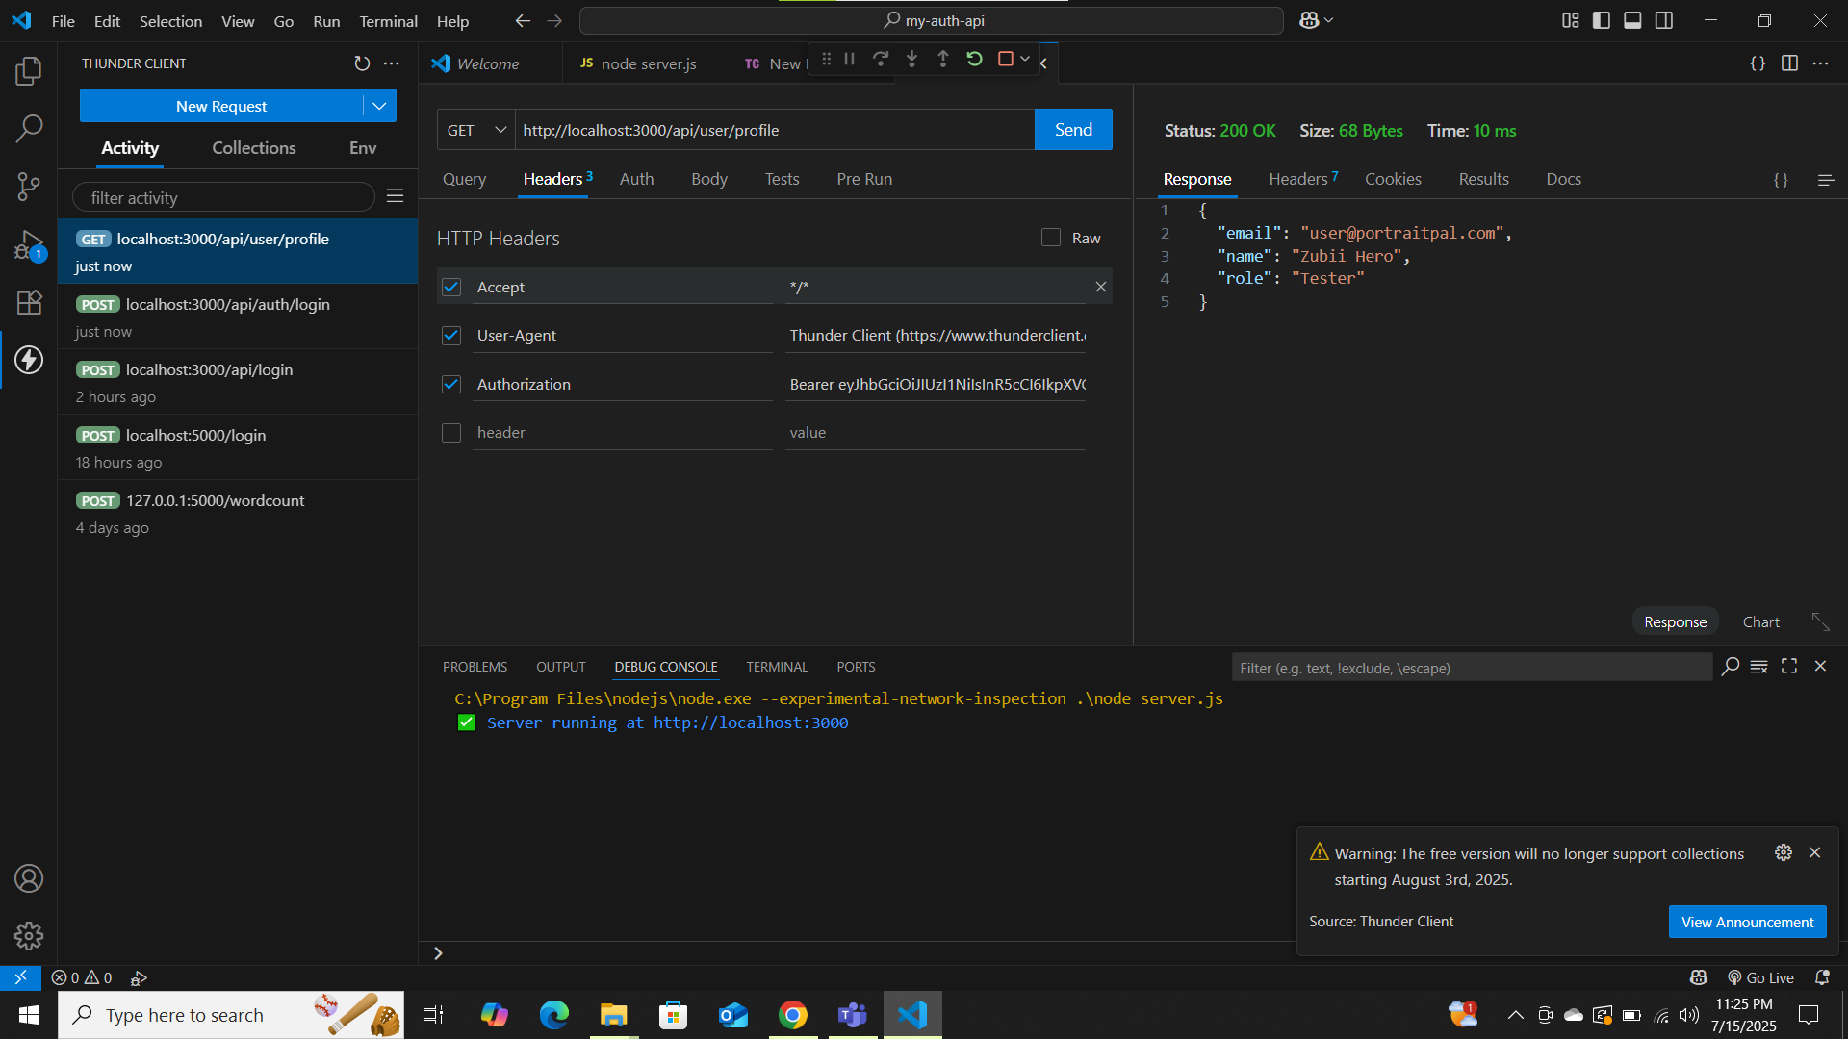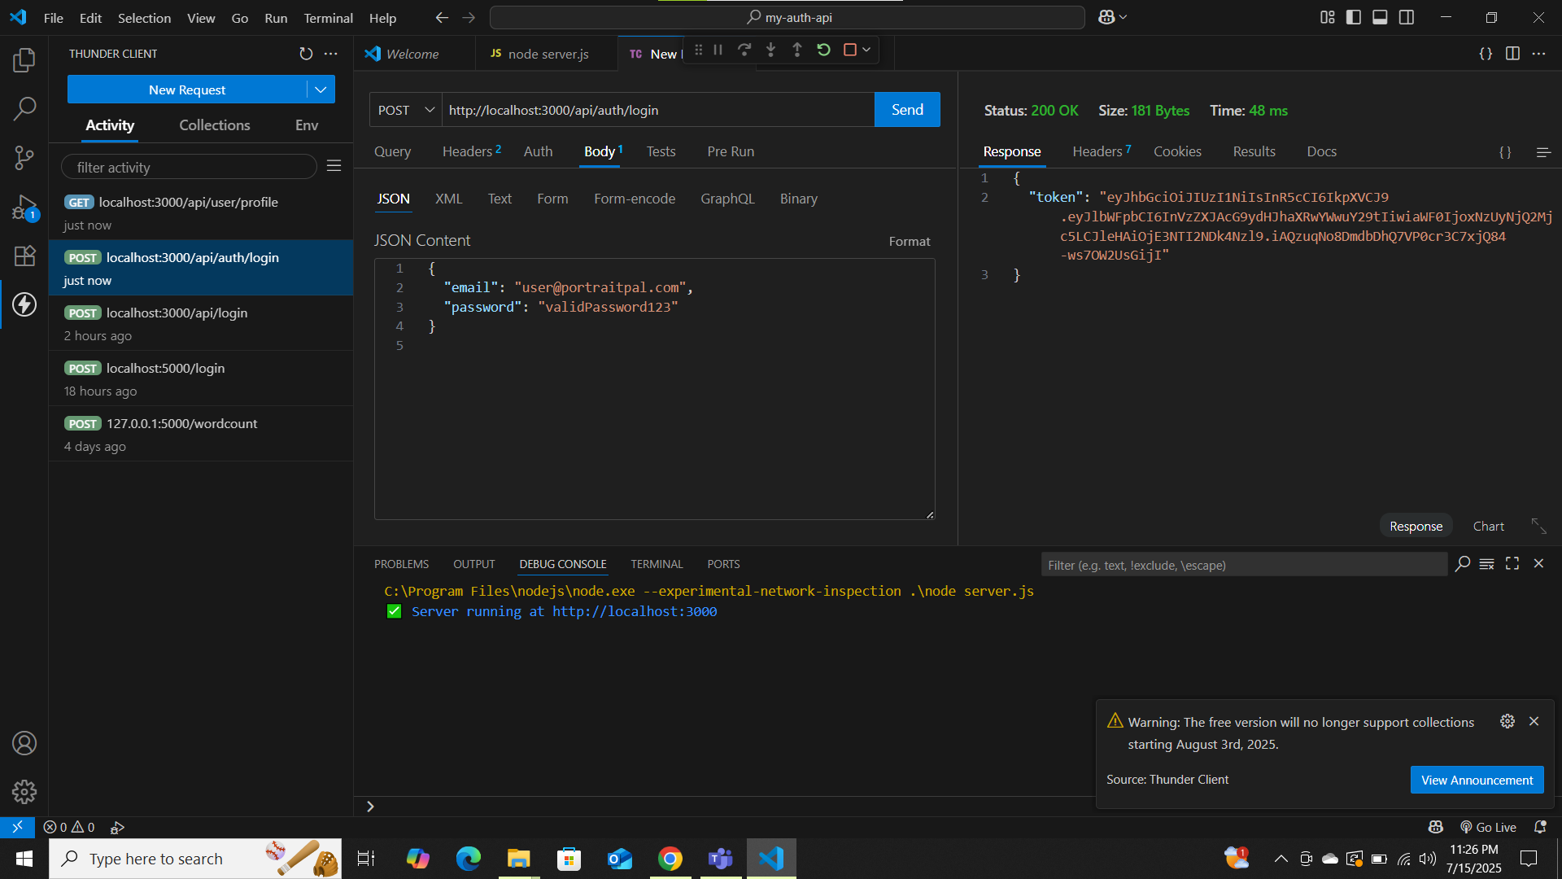

Task 2

Test1:

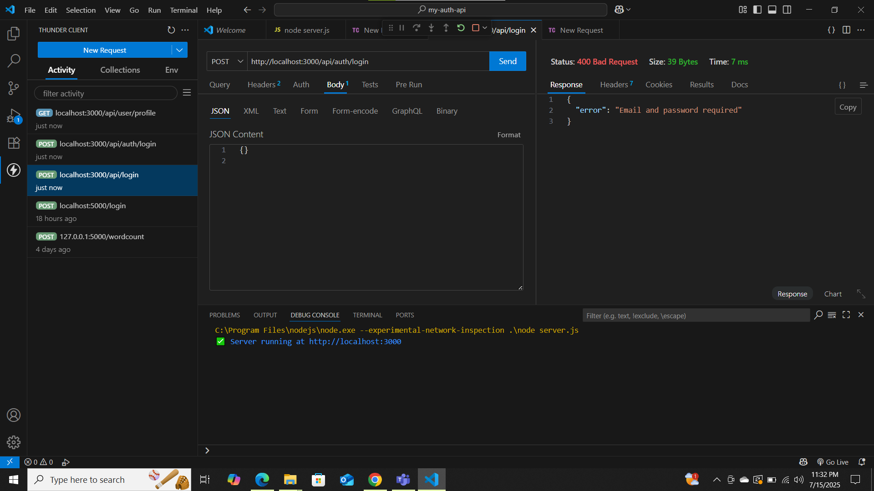

Test 2:

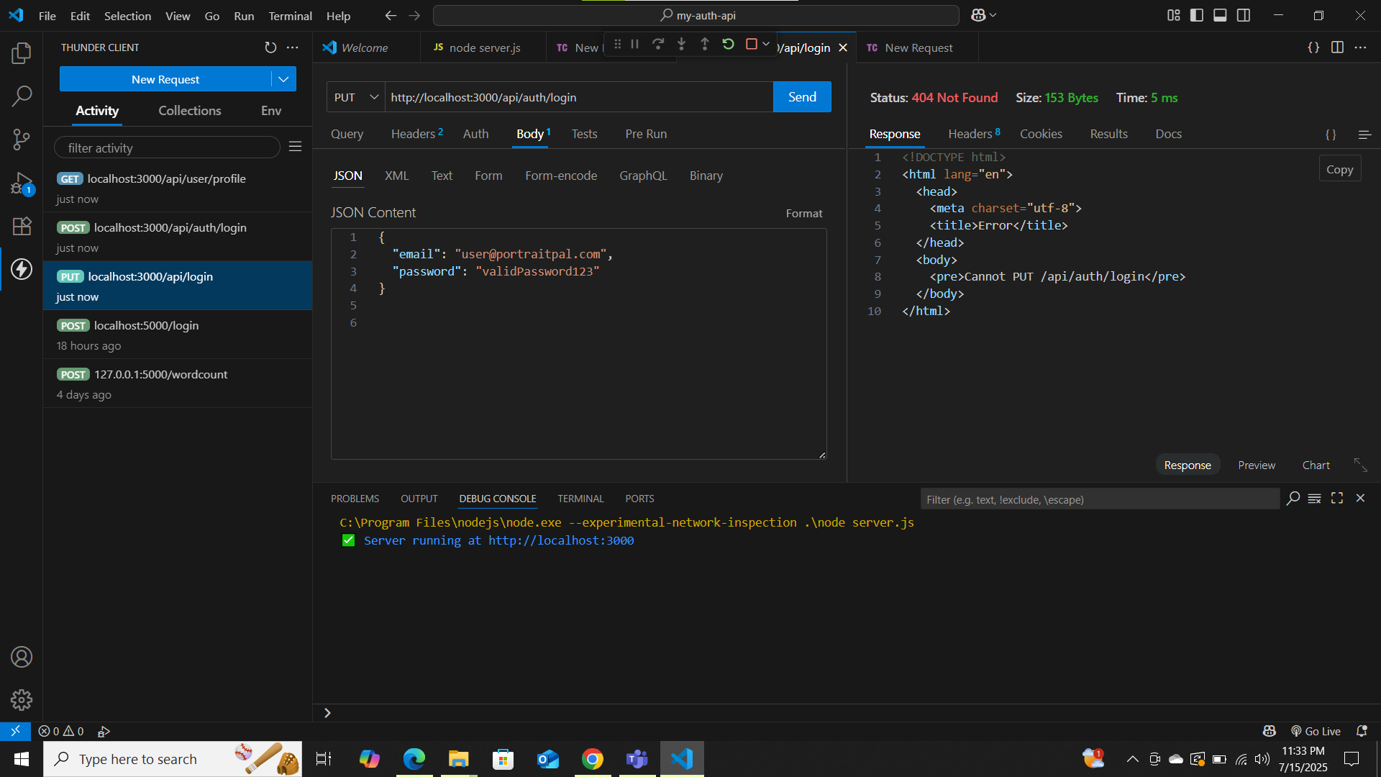

Test3:

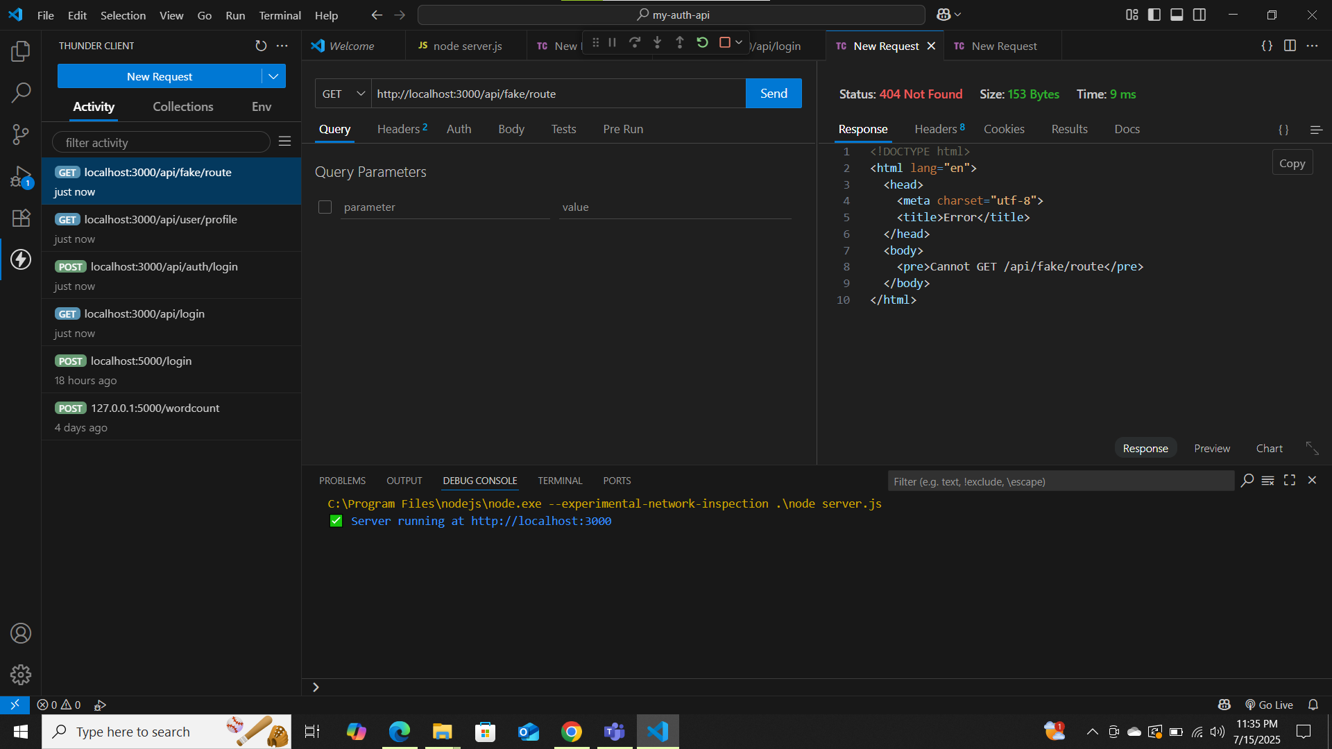

Test 4:

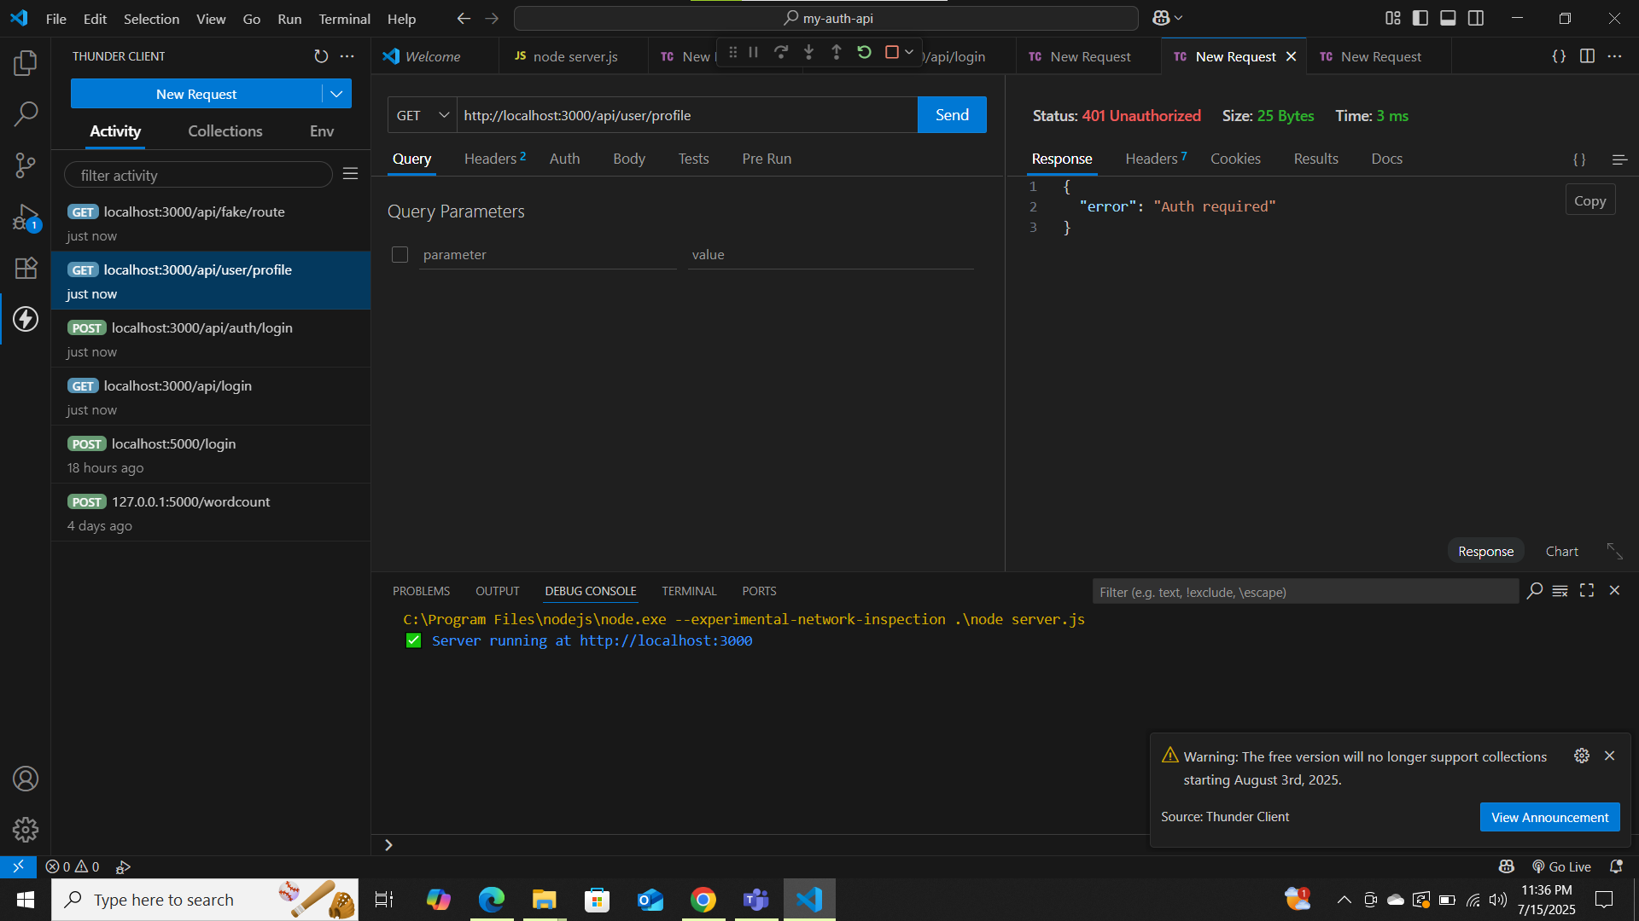

Test 5:

